**YUSEN LOGISTICS HOTEL REVENUE MANAGEMENT**

This Power BI dashboard leverages the power of Power Query transformation to deliver in-depth revenue analysis for a chain of hotels operating in multiple countries. The dashboard offers valuable insights into various key performance indicators, enabling stakeholders to make informed decisions and optimize the business strategy. The primary parameters and dimensions it covers are as follows:

**Parameters**

* **Average Daily Rate (ADR):** This metric reveals the average rate at which rooms are sold in the hotels, providing insights into pricing strategies and revenue per available room.
* **Total Nights:** Total nights booked at the hotels, helping track demand and occupancy trends.
* **Average Discounts Given:** This figure sheds light on the average discount offered to guests, allowing you to assess the effectiveness of pricing promotions.
* **Parking Spaces:** Analysis of parking space utilization, a critical factor for understanding guest preferences and additional revenue streams.

**Dimension**

* **Revenue by Year:** This dimension allows you to view revenue trends over different years, identifying growth or decline patterns.
* **Revenue by Type of Hotel:** Categorizing hotels by type (e.g., luxury, boutique, budget) helps in understanding which segments contribute most to revenue.
* **Revenue by Market Segment:** Segmenting the market by factors such as business, leisure, or events helps in tailoring marketing and sales strategies.
* **Revenue by Distribution Channels:** Understanding the revenue generated from various distribution channels (e.g., direct bookings, online travel agencies, corporate partnerships) assists in optimizing channel management.
* **Revenue by Reservation Status:** Analyzing revenue based on reservation status (e.g., confirmed, cancelled, pending) is crucial for managing occupancy and forecasting revenue.

This Power BI dashboard harnesses the power of Power Query transformations to clean, shape, and consolidate data from various sources, ensuring that the information presented is accurate and up-to-date. With visually appealing charts, graphs, and interactive elements, it provides a user-friendly interface for exploring and analyzing the hotel chain's revenue data.  
This tool equips hotel management and decision-makers with the necessary insights to make data-driven decisions, enhance pricing strategies, and refine marketing efforts to maximize revenue and operational efficiency. It serves as an asset for achieving a competitive edge in the hospitality industry.

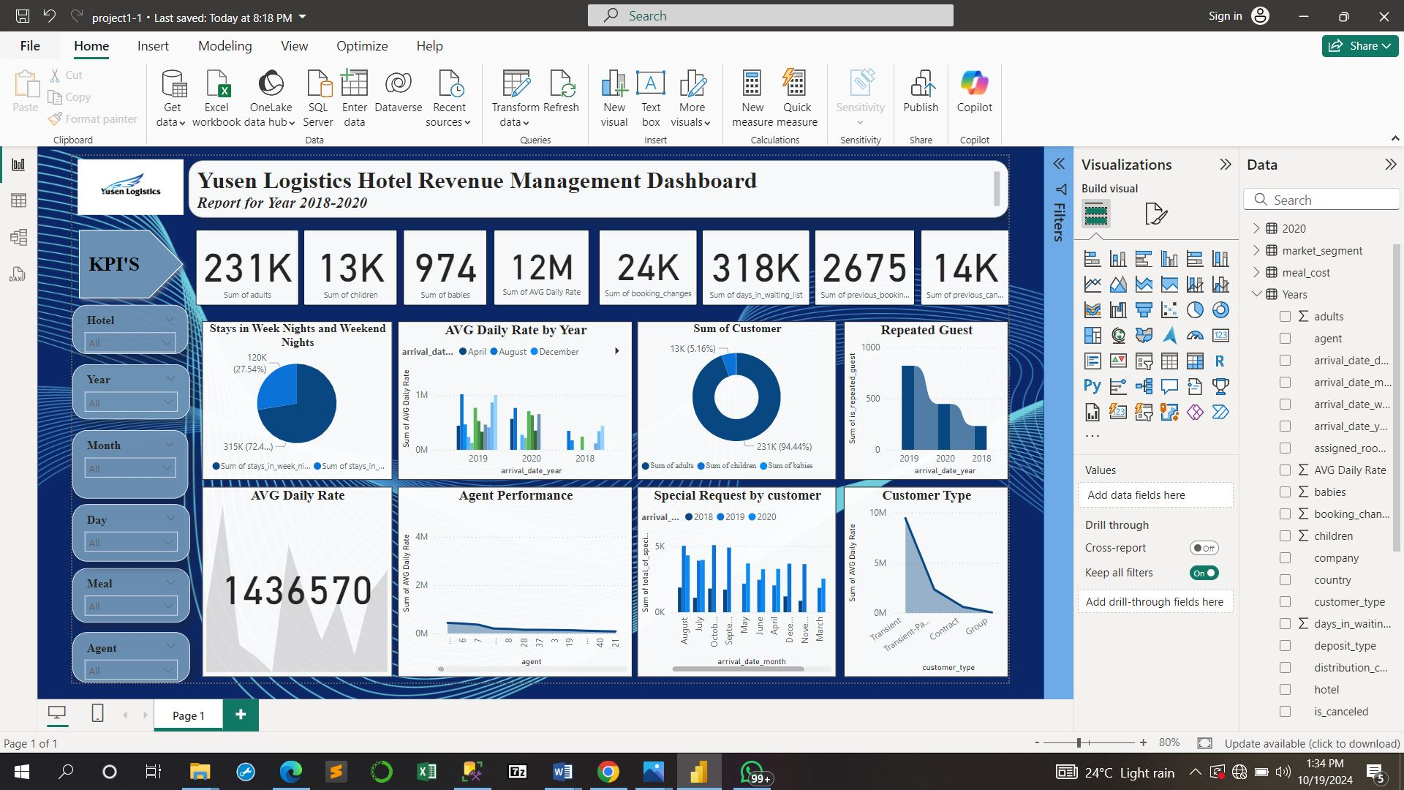

**Summary**

The dashboard gives a summary of the hotel performance over 3 years which will help the hotel make a business decision.

The average daily rate of **₦1,436,570** and the average daily rate from 2018 - 2020 being **₦12million.** There was a rise in the number of repeated guests over the years which is an indicator that Yunsen Logistics Hotel have also improved in their services over the years. Customers were mostly transient, meaning the hotel is considered home away from home by travelers or easily assessable to travelers due to it’s location. Yunsen has experienced more patronage during the week than weekends with 72.4% of customers staying on weeknights. Yunsen may want to consider activities that can increase patronage on weekend nights.

The dashboard has also shown the contribution of different agents to the performance of Yunsen over the years and a reward system can be put in place based on the performance.

Overall, Yunsen can make use of the analysis for decision making.